# Information:

An Unmanned Free-Swimming Submersible (UFSS) vehicle is shown in Figure 1. The depth of the vehicle is controlled as follows. During forward motion, an elevator surface on the vehicle is deflected by a selected amount. This deflection causes the vehicle to rotate about the pitch axis. The pitch of the vehicle creates a vertical force that causes the vehicle to submerge or rise. The pitch control system for the vehicle is used here. The block diagram for the pitch control system is shown in Figure 2*.* In this case study, we investigate the time response of the vehicle dynamics that relate the pitch angle output to the elevator deflection input.

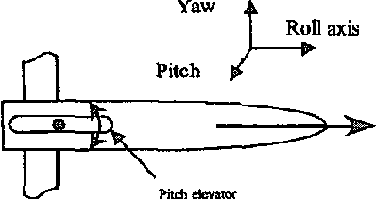

# Code for MATLAB Plot:

K1 = 1;

K2 = 1;

num = [0.25*K1 0.10875*K1];

den = [1 3.456 3.20688+0.25*K2 0.6105497+0.25*K1+0.10875*K2 0.041574+0.10875*K1];

G1 = tf(num, den);

t = 0:0.01:50;

figure;

step(G1, t);

grid on;

title('Step Response of G1');

ylabel('Pitch Angle (rad)');

xlabel('Time (sec)');

# Output:

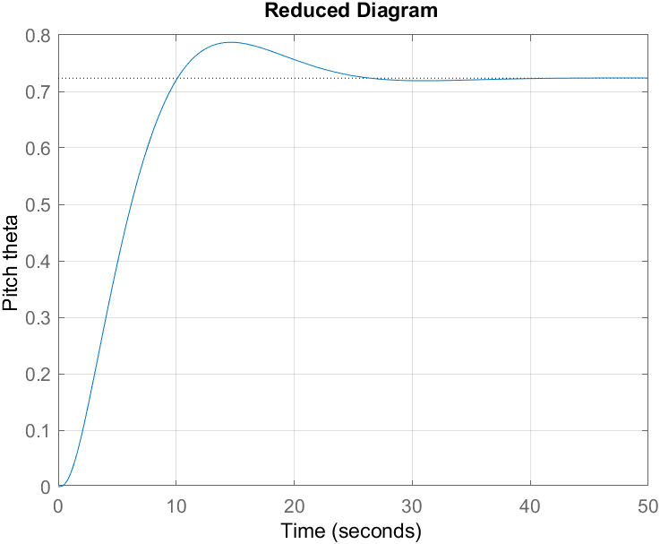

# Control Loop Block Diagram

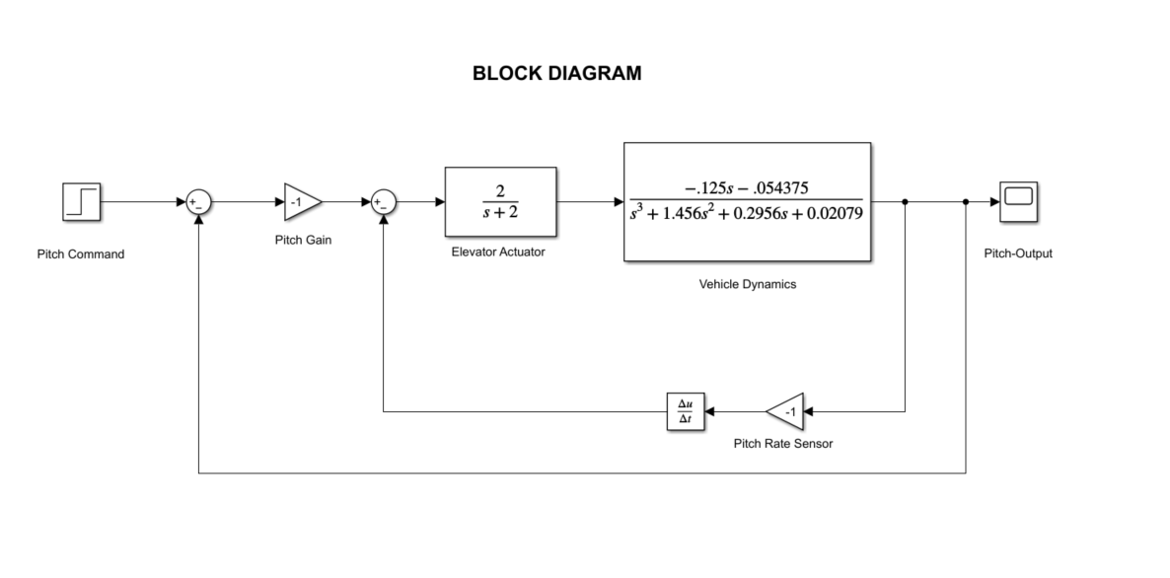

## Graph

# Reduced Control Loop Block Diagram:

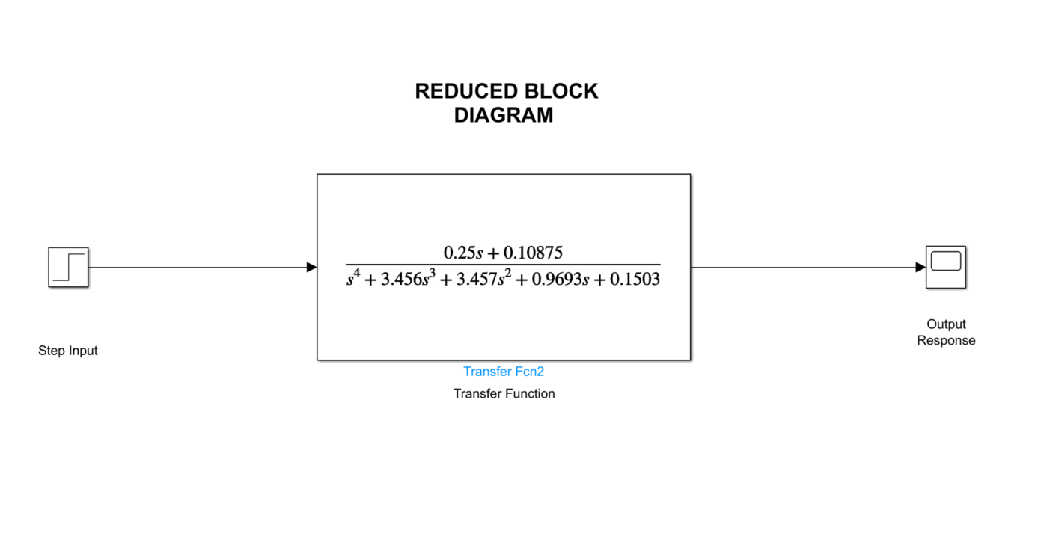

## Output

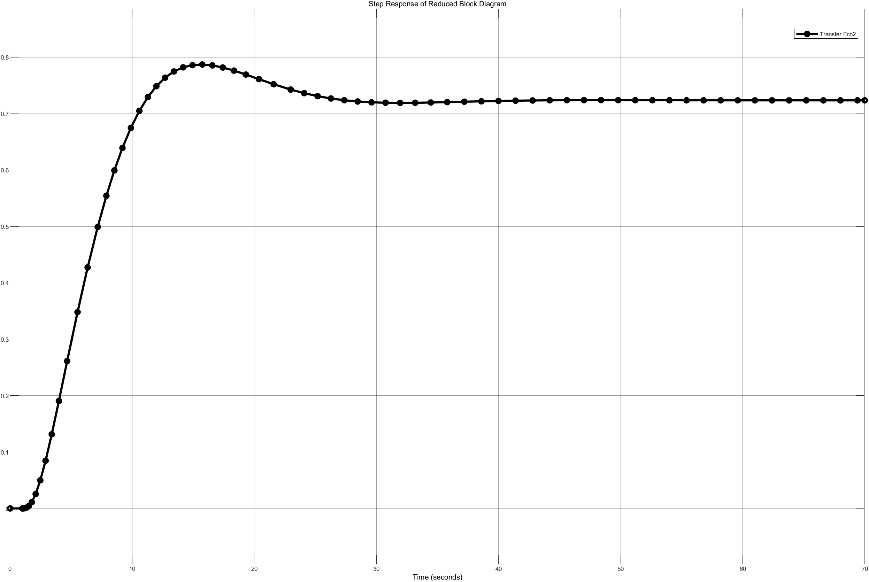

# Comparison of both Block Diagrams:

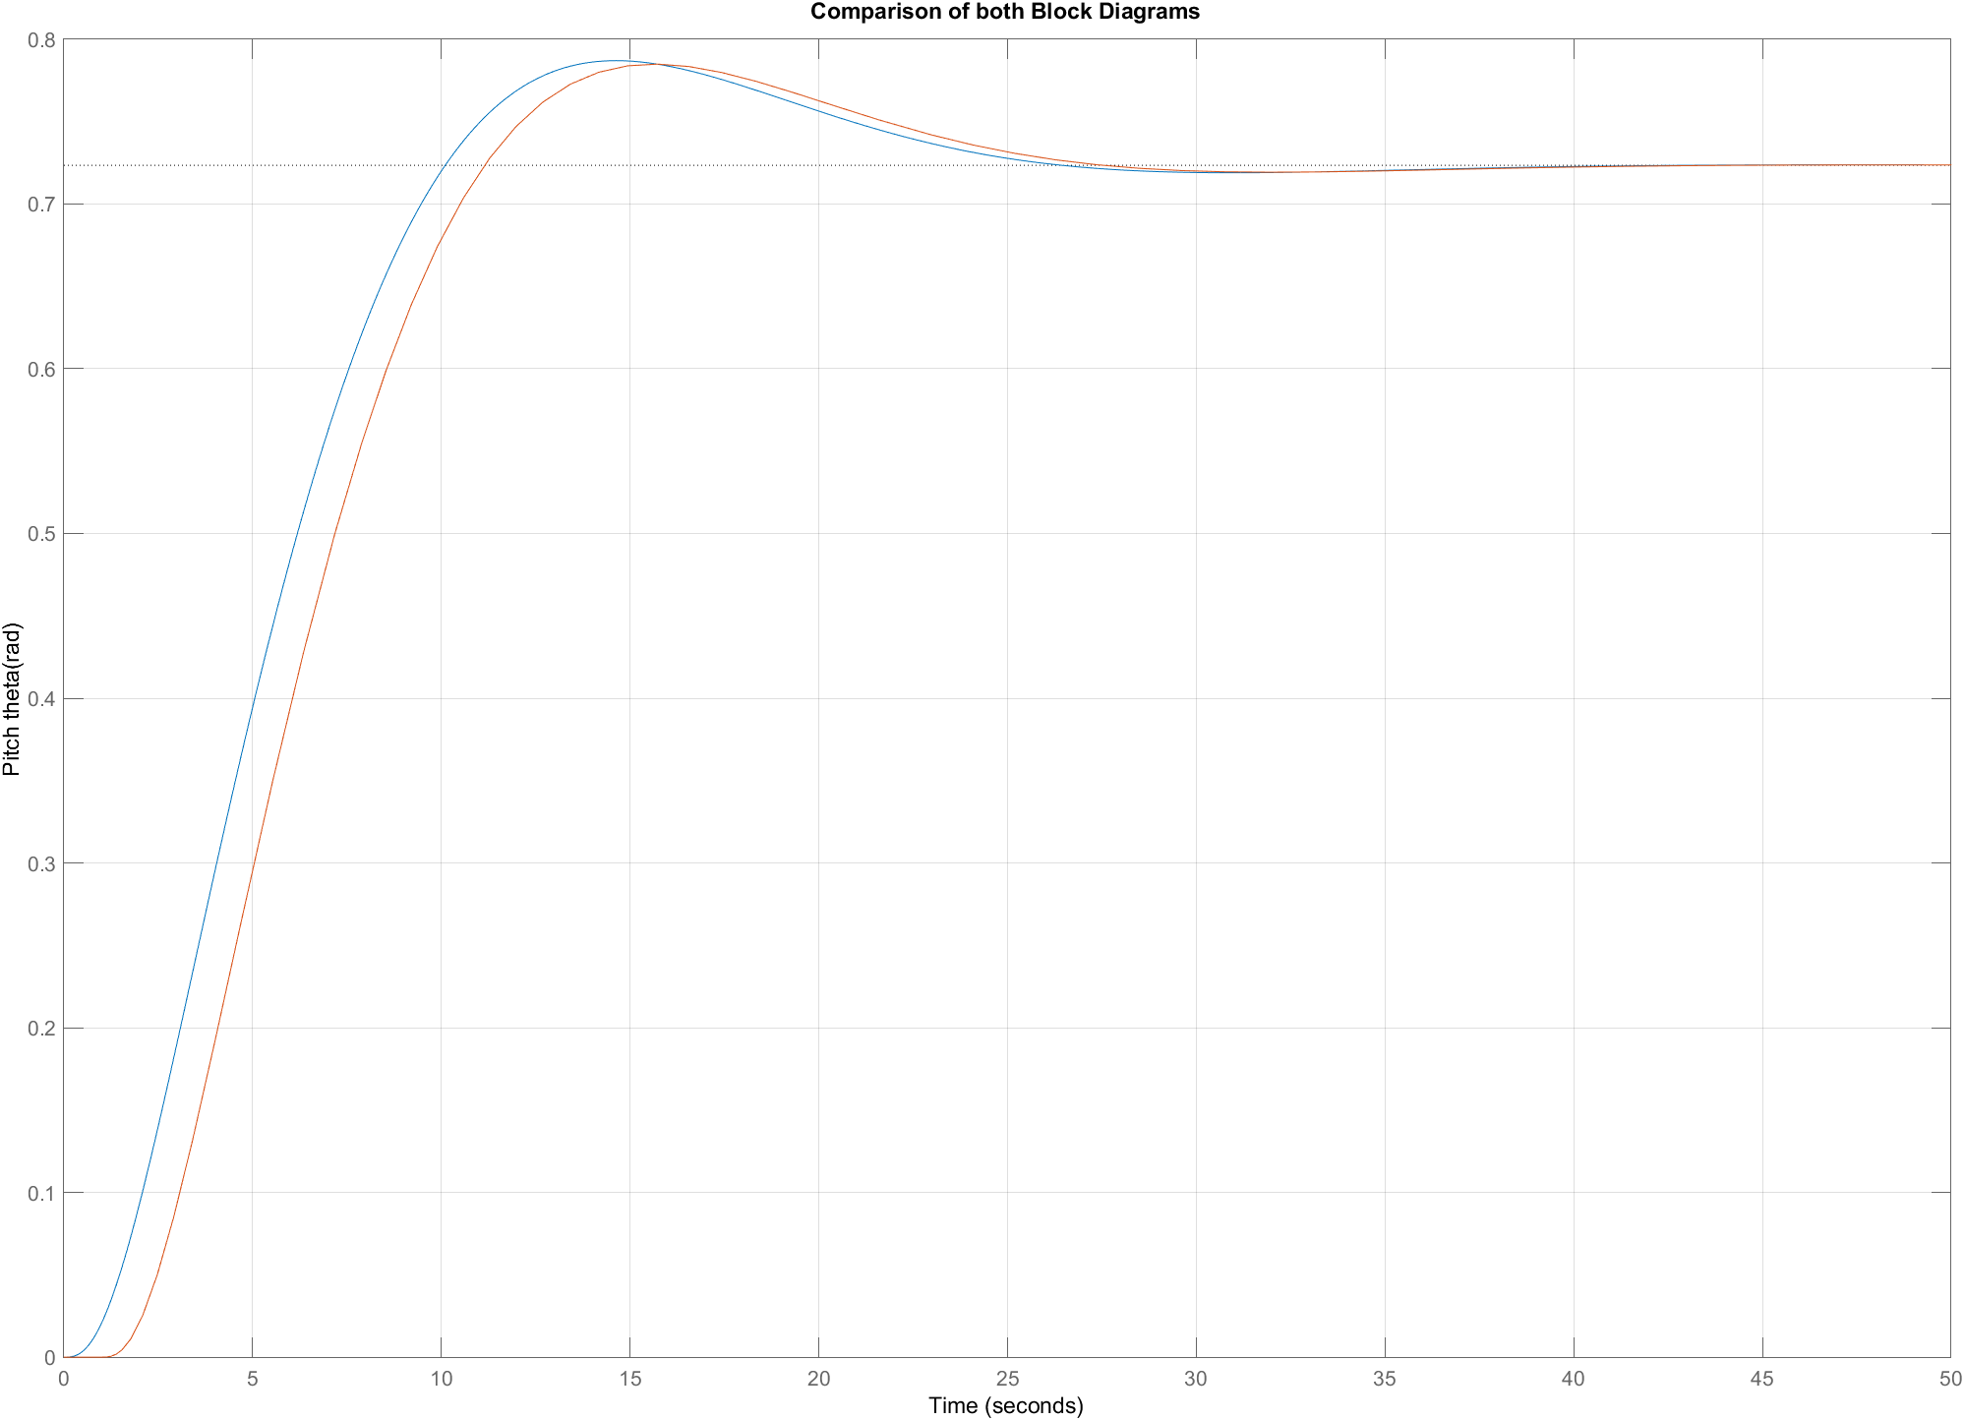

# Explanation:

Although the response of the two appears to be dissimilar, this can be attributed to slight discrepancies resulting from MATLAB's rounding off coefficients to four decimal places during the construction of the transfer function. Moreover, incorporating a derivative block in Simulink may lead to a certain degree of noise in the system, thereby further contributing to the observed variations. It is important to note that ideally, the two responses should be precisely identical.